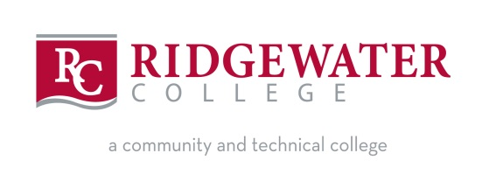
Ridgewater College - Practical Nursing Application for Fall 2024

Full Name__________________________________________________________________________
First Middle Last Maiden
Mailing Address_______________________________________________________
_______________________________________________________

Home Phone: _________________________ Cell Phone: __________________________________

E-mail Address________________________________________________________________________

Ridgewater Student ID No.__________________________ STAR ID:__________________________
(You must already be an accepted Ridgewater College student to apply)

Which campus are you applying to? Willmar only__ Hutchinson only___ Both ___
If you want to be considered for acceptance on BOTH campuses and your ranking would allow us to accept you to either campus – what is your preferred campus?
Willmar or Hutchinson (please circle one only)

Did you attend a Nursing Information Session? _______ (Yes or No)

Are you on the current on the Minnesota Nursing Assistant Registry? This is required and will be verified with the Minnesota Board of Health.
YES_______ NO______

Selection Criteria
GPA from the following courses is used in the ranking of PN applicants. Please list the information for the various courses:

 | Institution | Semester | Year | Grade
PRNU 1617 or HLTH 1130
Psychology 1310
ENGL 1209 or ENGL 1210
BIOL 1080 or BIOL 2100/BIOL 2110

I certify that the information given on this application form is accurate information. I understand that false or inaccurate information will void my application. I understand that I am applying for the Practical Nursing Program, which does not allow direct admittance to the RN program.

Applicant signature Date
Please keep a copy of this application for your records.

SEND COMPLETED APPLICATIONS TO:
Ridgewater College
Admissions Office – Matt Roberts
2 Century Avenue SE
Hutchinson, MN 55350
Application questions can be directed to:
Matt Roberts – Hutch Campus – (320)234-8505 matt.roberts@ridgewater.edu
Ellery Knight – Willmar Campus – (320)222-6071 ellery.knight@ridgewater.edu

